Wind Energy Engineering NE6003:

Measure Correlate Predict (MCP) assignment

Measure Correlate Predict Instructions

- Use the data in the files contained in \\denovo\public\ne_6003\assignments.labs\MCP\
- Copy the data to your personal folder.
The reference site data is in standard meteorological format. Wind speeds are reported in knots, to the nearest knot. (1 knot = 0.514 m/s).
The wind farm met mast data is in typical format for a wind farm study.

Preprocessing tasks
The data from both locations should be vertically extrapolated to the same height before the MCP analysis is commenced. The highest measurement level of the wind farm met mast is a suitable target height for the vertical extrapolation. The reference site has land cover of low-cut grass with no significant nearby terrain features or changes in surface roughness.
It will be noted that the time resolution of the data sets is not the same. A suitable approach must be taken to compare like-for-like data from each site.

MCP Assignment tasks

- Calculate the Pearson product-moment correlation coefficient (r) between concurrent reference site and wind farm site wind speeds.
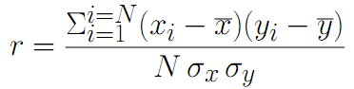
Where σ denotes the standard deviation, x is reference site wind speed and y is wind farm site wind speed.
- Calculate the linear (slope, intercept) regression coefficients for regression of wind farm wind speeds on to reference site wind speeds.
- Use these regression coefficients to generate a series of predicted wind speeds for the wind farm site over the full time range of available reference site data.
- What is the mean wind speed for each year of (a) reference site; (b) wind farm site measured data; (c) wind farm site predicted data.
- What is the root-mean-squared error of wind farm site predicted wind speeds (y) compared to wind farm site measured wind speeds (x)?

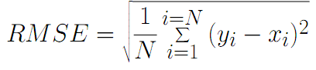

What is the bias or mean error, in degrees, of the wind direction from the reference site in comparison to the wind direction from the wind farm site?
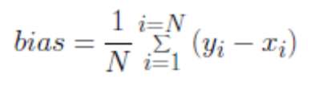

What is the uncertainty in the long term annual mean wind speed estimate for the wind farm site, i.e. the standard deviation of adjusted annual mean wind speed from MCP?

Notes

- Use Matlab or Microsoft Excel or another computer program for your calculations and show all formulae or code used.

- NB : most mathematical packages have many built-in functions to assist with statistical calculations.

- To avoid ‘wrap around’ issues for wind direction errors, add 360 degrees to all recorded wind directions from both sites.

